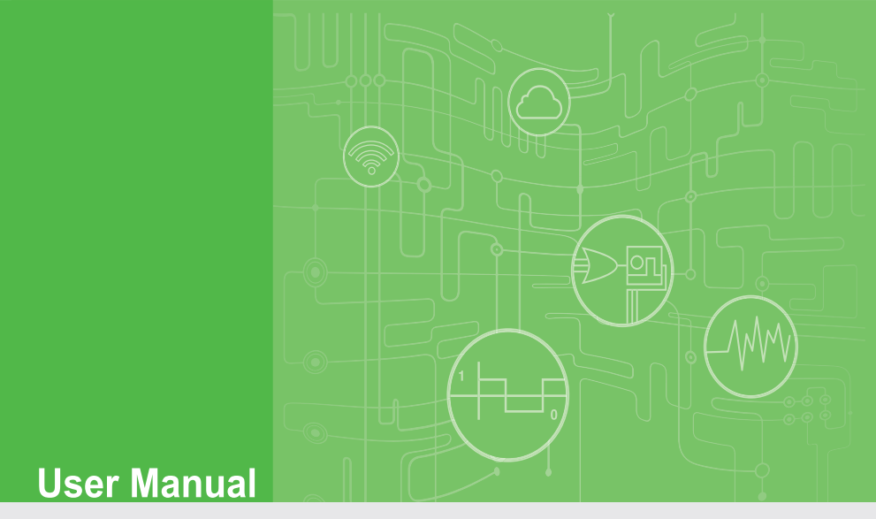**User Manual**

**Private Server**

**for WISE-4000 Series**

**(.NET version)**

CONTENTS

1. Introduction 5

1.1. About This Manual 5

1.2. Organization of This Manual 5

2. Installations 8

3. Configuration of Private Server 10

4. Troubleshooting 15

4.1. Private Server Start-up error 15

4.2. No log received in Private Server 21

**Chapter** **1**

# Introduction

## About This Manual

This document describes the installation and usage of sample Private Server (.NET version) for Advantech WISE-4000 series IoT Wireless I/O Module products.

For WISE-4000 series, system log could be sent to a private log server instead of a public log server (for example: DropBox). A private log server is a web server which accepts a client’s log via http or https protocol. These logs include Push Notification Logs(IO data and System Event, both in JSON format) and Upload files(IO data and System Event, both in csv format). In this document, we will describe the steps of building a simple Private Log Server by using Microsoft Visual Studio 2008.

## Organization of This Manual

This user manual is divided into the following sections:

* Introduction
* Installations
* Configuration of Private Server
* Troubleshooting

**Introduction** This section gives the user a basic idea of this manual.

**Installations** This section provides instructions on how to compile and install Private Server.

**Configuration of Private Server** This section gives the new user a walk-through in configuring private server.

**Troubleshooting**

This section provides instructions on how to troubleshooting for operation mistakes or errors.

**Chapter** **2**

# Installations

Before running sample Private Server, you have to install Microsoft Visual Studio 2008 or above version on your PC. Please follow below steps to compile sample Private Server program.

1. Execute Microsoft Visual Studio 2008.
2. On the menu bar, choose File🡺Open🡺Project/Solution and navigator to the folder where your Private Server program is located.
3. On the menu bar, choose Build🡺 Build Solution.
4. Execute program by choose Debug🡺Start Debug.
5. You will see below figure.

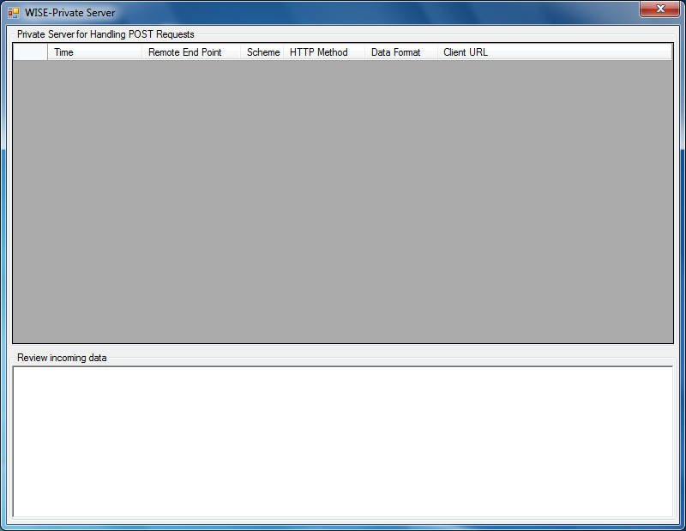

Note: If you have problem when executing program, please refer Chapter 4 for trouble shooting.

**Chapter** **3**

# Configuration of Private Server

If you finish installing software described in Chapter 2, please proceed following steps to configure sample private server.

Several parameters of Private Server sample program could be modified, please open Form1.cs and refer to below table and figure:

|  |  |
| --- | --- |
| Variable | Description |
| HTTP_Prefix | Listen Port of Private Server HTTP Web (default 8000). |
| HTTPS_Prefix | Listen Port of Private Server HTTPS Web (default 8080). |
| Url_File_UploadLog_Token | Private Server Web URL which receives WISE device’s data file (csv format) upload. |
| Url_Json_IoLog_Token | Private Server Web URL which receives WISE device’s push notification of IO data (JSON format). |
| Url_Json_SysLog_Token | Private Server Web URL which receives WISE device’s push notification of System event (JSON format). |

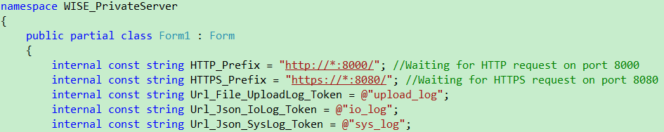

If your configuration on WISE device is correct, you will see below figure which shows logs are received correctly.

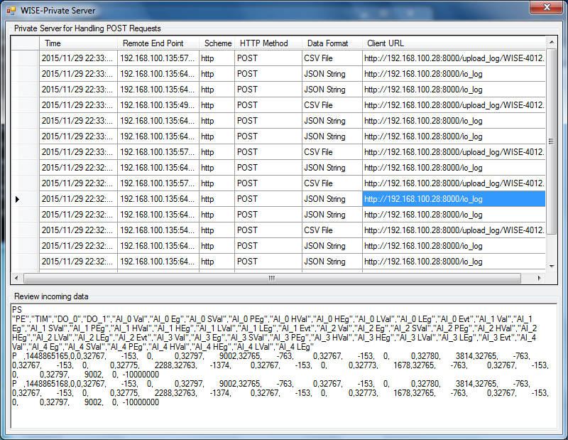

The Push notification log will be saved in the path where sample program is located. Following figure shows Push notification files received by Private Server.

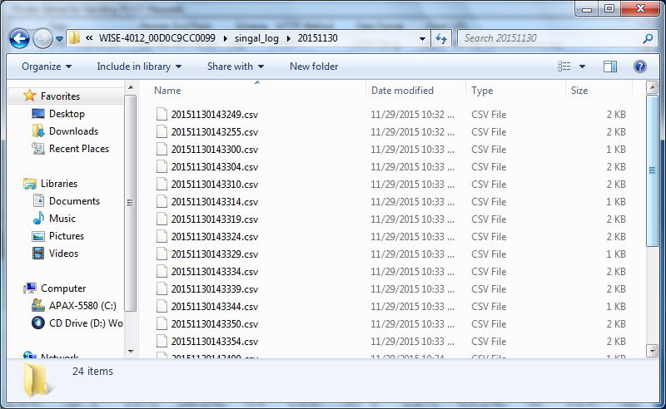

Please make sure you have performed the corresponding Private Server configuration in WISE device. Please refer to the following figure:

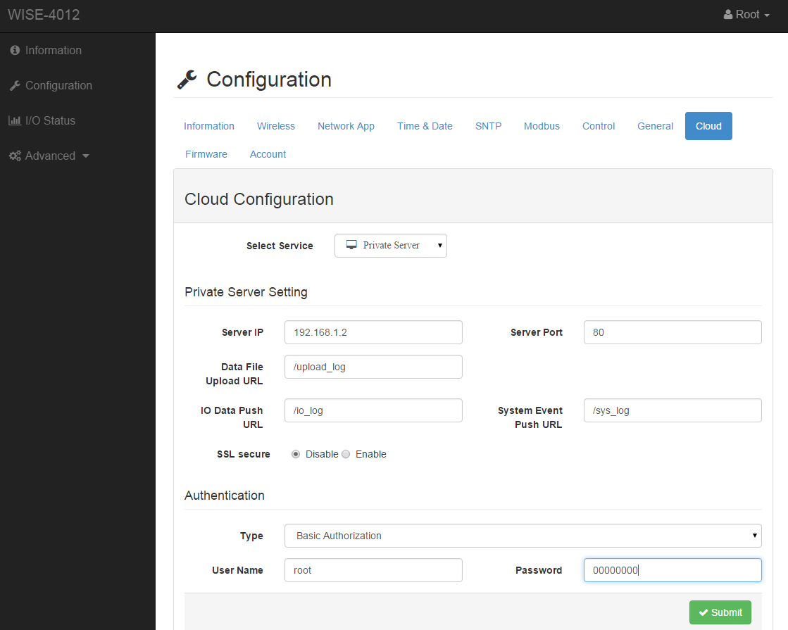

Note: If you want to execute Private Server with HTTPS enabled, please refer to 「How to configure a port with an SSL certificate」document which is located in “WISE-PrivateServer\SSL Cert” folder.

**Chapter** **4**

# Troubleshooting

## Private Server Start-up error

You may see below error message box when start-up private server:

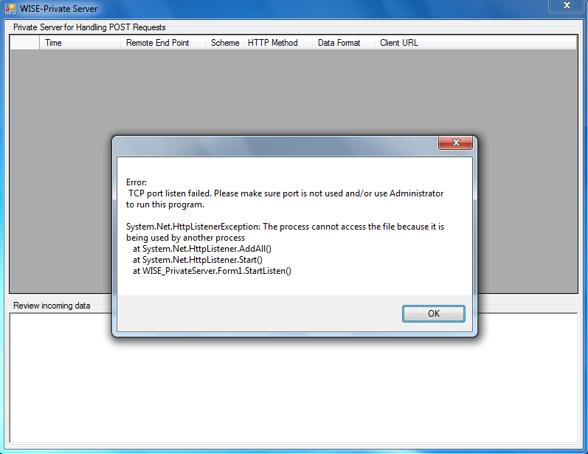

Due to different settings of each computer, there are several possibilities that cause this error. Please check following methods:

* Method1: The listen port of Private Server may be used by other program on your computer. Please close any program that uses port 8000/8080 or choose another port number (e.g. 8080) for your own program.
* Method2: Use administrator privilege to open Microsoft Visual Studio 2008 and execute Private Server sample program. This could be achieved by clicking mouse right button and choose “Run as administrator”.
* Method3: The listen port of Private Server may be blocked by Windows Firewall. Please choose one of following methods to un-block Windows Firewall.
  + Method 1: Disable Windows Firewall:

In Windows Startup Menu, choose 「Control Panel」🡺 「System and Security」🡺「Windows Firewall」. Select “Turn Windows Firewall on or off” in left menu and choose “Turn off Windows Firewall” in Home or work network location settings and Public network location settings.

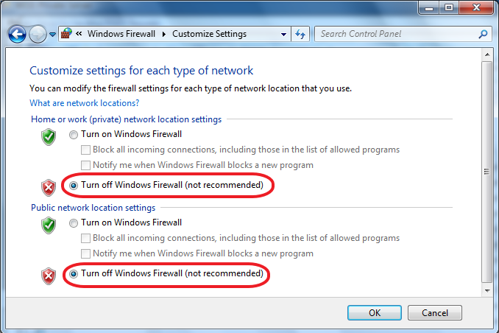

* + Method 2: Add Windows Firewall Rule:

1. In Windows Startup Menu, choose 「Control Panel」🡺 「System and Security」🡺「Windows Firewall」. Select “Advanced settings” in left menu and you will see below figure:

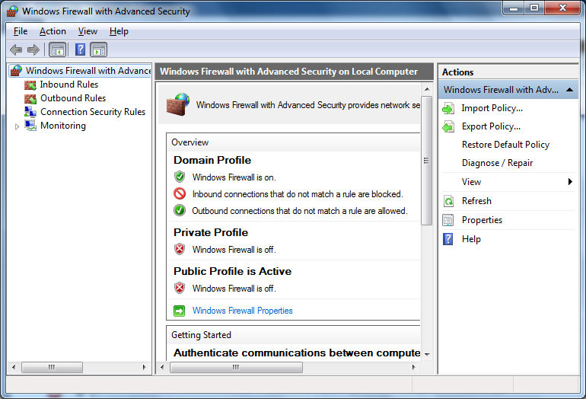

1. Please choose Inbound Rules and click “New Rule” in right menu.

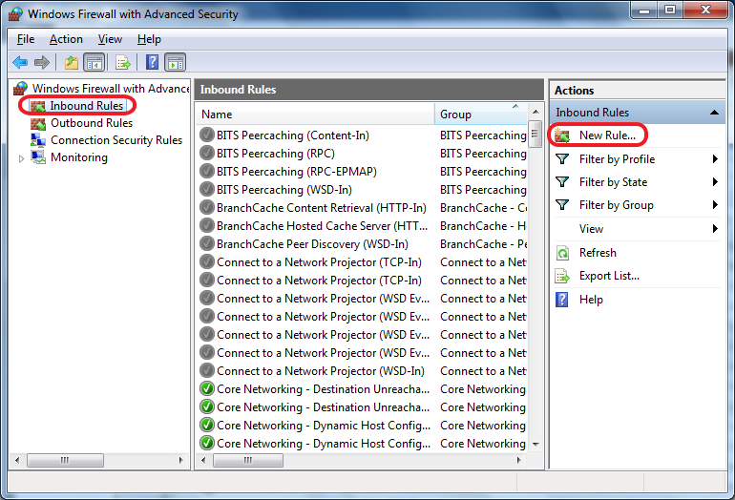

1. In New Inbound Rule Wizard, choose Port and press “Next”.

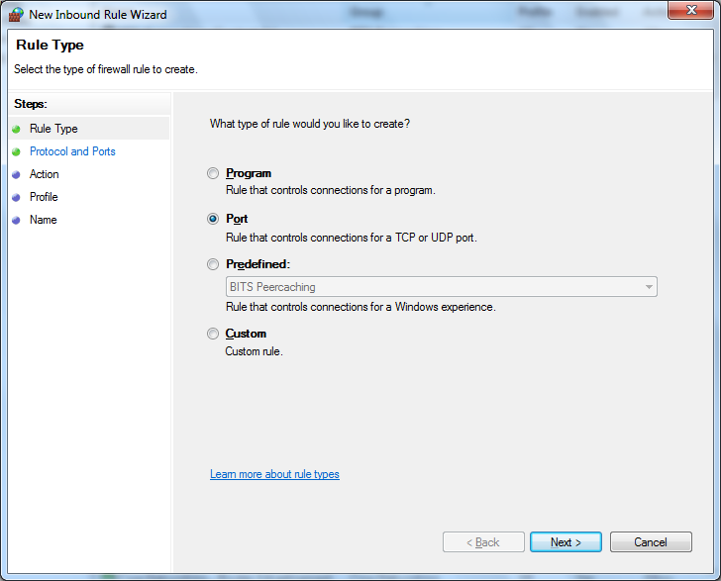

1. Choose TCP and add Specific Local ports: 8000, 8080 for Private Server.

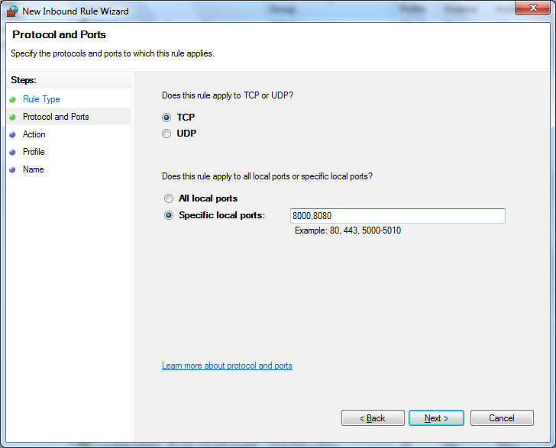

1. Choose Allow the connection.

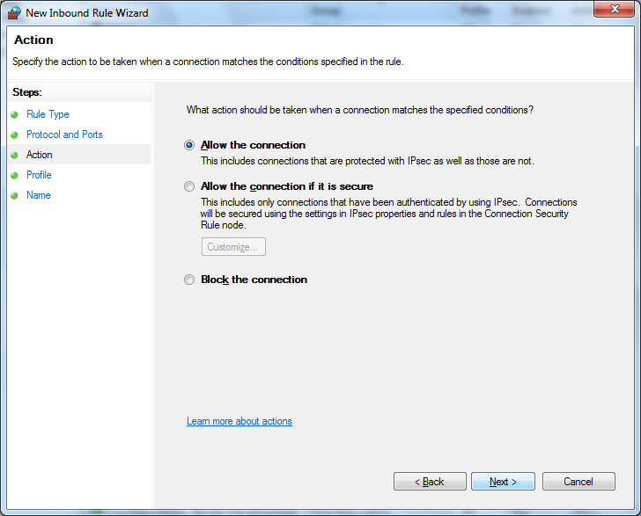

1. Press next.

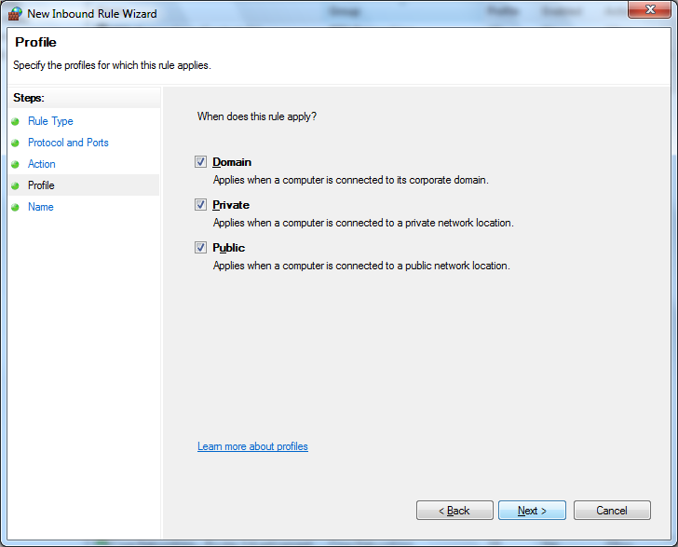

1. Name this firewall rule as Private Server and press “Finish”.

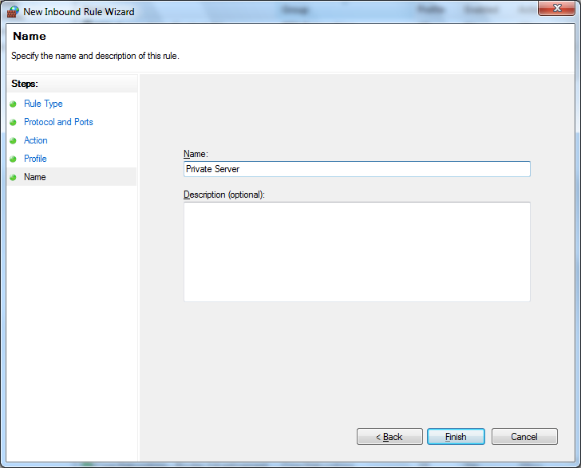

1. You will see added rule in Inbound Rules. This rule will allow Private Server to receive incoming WISE logs.

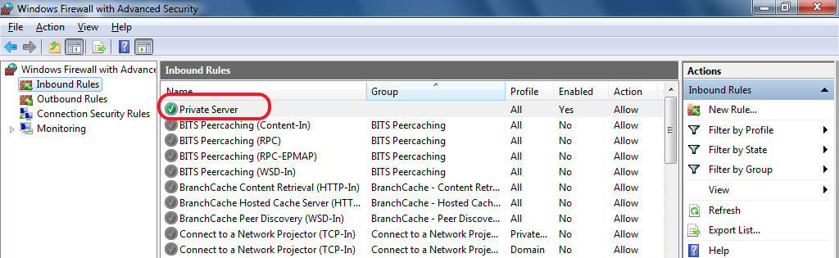

## No log received in Private Server

Step 1: If you want to receive upload csv file, please make sure IO log or System Log in WISE is turned on in Memory Storage of Data Logger configuration. Then turn on Cloud Upload in Data Logger configuration.

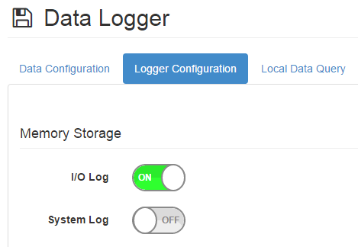

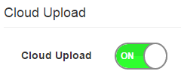

Step 2: If you want to receive Push Notification of IO Log or System Log, please make sure the corresponding items are turned on in Data Logger configuration.

